Project Acceptance Conformity for Radar 77 G1.3 Burn In Fixtures

Project: 77 G1.3

EPT-RDR0277Ghz-06-01--16

RESTRICTED ACCESS

DISTRIBUTION :
Firm Recipient Copies
CFM Jason Cai 1
CFM Elieen Qi 1
CFM Daniel Wang 1
CFM Steven Wu 1

REVISION

Revision Date Author Comments

A 2021-09-30 Jason Cai Initial Release

CONTENTS

1. REFERENCE 4
2. OBjective 4
3. Method of measurement 5
4. List of the ACCEPTANCE CRITERIA for the burn in system 6
5. Conclusion 6

REFERENCE

Trial date: 2021/09/30

Trial done by: Jason Cai

Product: 77 G1.3

Station of Test: Burn In
Fixture: EPT-RDR0277Ghz-06-01--16

Software: CIMTEST、CVI

OBjective
Verify the conformity of 77 G1.3 Burn In Fixtures with the production requirements and validate it can be used for production.
. 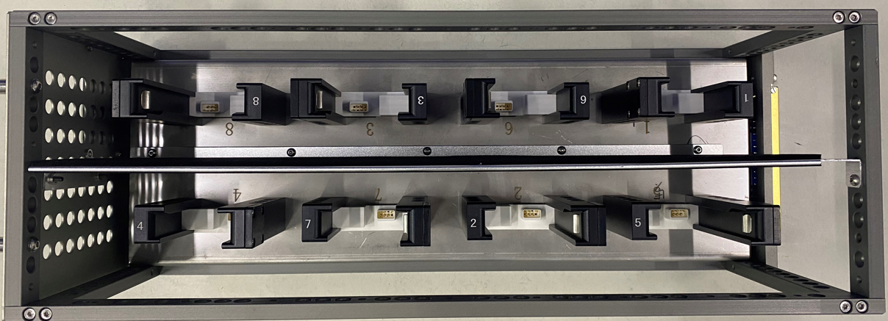
Fixture

Method of measurement
The acceptance criteria has been defined and listed for the BI fixtures and the system will be verified to meet the acceptance criteria.

List of the ACCEPTANCE CRITERIA for the burn in system
The SAFE LAUNCH - VALIDATION PLAN result list in the following attachment.

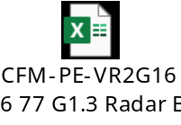

Conclusion
The Radar 77 G1.3 Burn In Fixtures are conformed to meet the acceptance criteria and production requirements.

